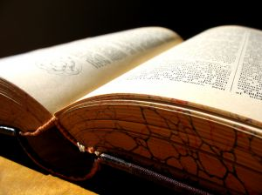
Skakespeare:
His life and times

Group 6: Literary Terms Relating to Shakespeare
Define and give an example of each. ** Use a dictionary or other source in addition to the Web sites.
- sonnet (Shakespearean):
Fourteen line poem witch is writing in iambic pentameter. The Shakespearean, divided in three quatrains and a couplet.

For thy sweet love rememb'red such wealth brings,
That then I scorn to change my state with kings.
William Shakespeare

- iambic pentameter:
A commonly used metrical lines in traditional verse and verse drama. It discribed the rythm that the words etablish.. This rythm is mesured in groups of syllables called feet. It is created by the alternation of short and long syllables and the alterrnation of unstressed and stressed syllables.

- blank verse :
Popular in the sixteenth and the seventeenth century, it's an unrymed iambic pentameter.

But God left free the Will, for what obeys
Reason, is free, and Reason he made right,
But bid her well beware, and still erect,
Lest by some fair appearing good surpris'd
She dictate false, and misinform the Will
To do what God expressly hath forbid.

- soliloquy:
When the character speak his thought aloued while alone..

To be or not to be
William Shakespeare

- foreshadowing:
The use of hints or clues to suggest sth wich will happened later.

what’s going to happen?

- apostrophe:
When sth or sbd is directly addressed

Death be not proud, though some have called thee / Mighty and dreadful.
Jhon Donne

- oxymoron:
Two contradictory words put together.

The Greeks in a proverb do express it properly in two words, which I can none otherwise interpret in English, but `speed thee slowly'
Thomas Elyot

- hyperbole
- irony (dramatic)
- irony (verbal)
- allusion
- motif
- pun
- personification
- couplet

Useful links:
Definitions
More Literary Terms

