The living conditions in 19th century in London
The 19th century wasn’t a good century for the Londoners, indeed the living conditions was deplorable. Cholera epidemics, the “Great stink”, miasmas, all of this created the higher death rate since the Black Death. The government had to react and quickly to re-establish the situation.
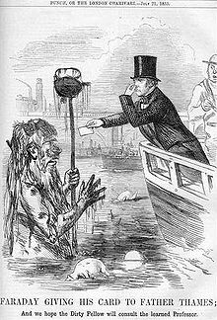
Live in town in this century meant more chance to find a job, an escape of the poverty and hope for a longer life. But finally it was the opposite. Epidemics have developed because of the environment which became increasingly unclean. Polluted water, lice, human waste and others problems was the due to the increase of epidemics. It was easy to identify this problem, but not to resolve it.

The Great Stink (or Big Stink) was during the summer of 1858 in London, it was a smell of human waste. The introduction of flush toilet (which replacing the chamber-pots) was one of the cause of the Great Stink. It gradually contaminated the River Thames and the stink began progressively.
Because of the problems of bad conditions in houses, in 1870 they decided to build new and healthier housing. The Public Health Act of 1875 imposed that each house will be self-contained with its own sanitation and water.
Despite a 19th century difficult for the Londoners, they succeeded to overcome epidemics, and people gradually had access to healthier housing.

