*Country Lovers,* a short story by Nadine Gordimer *(*1980)

**Before you read** the story, discuss with your partner(s) the meanings of the words given below. Write a definition or give an example for each, and decide whether the words can be arranged in pairs or groups.

Apartheid

Privilege

Deprivation

Segregation

Integration

Taboo

Prejudice

Tolerance

**Now read the story.**

**When you have finished it**, look again at the list of words and discuss their application to the events in the story.  
Do any not have a place?

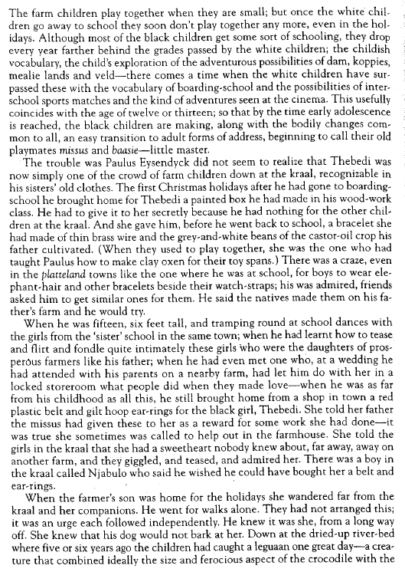

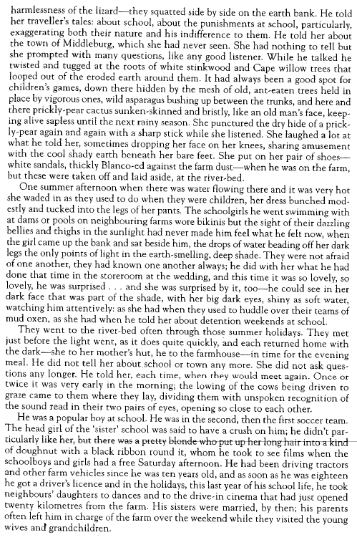

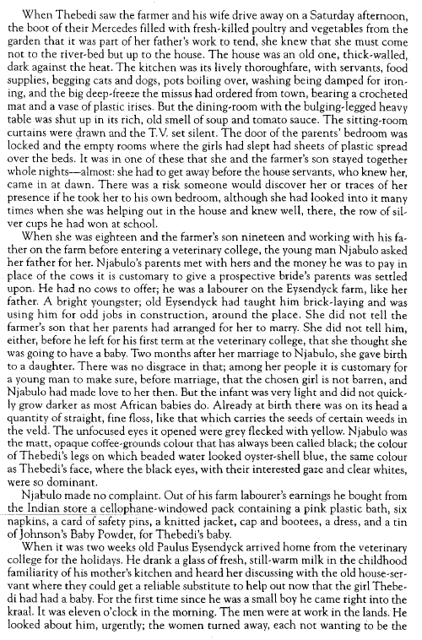

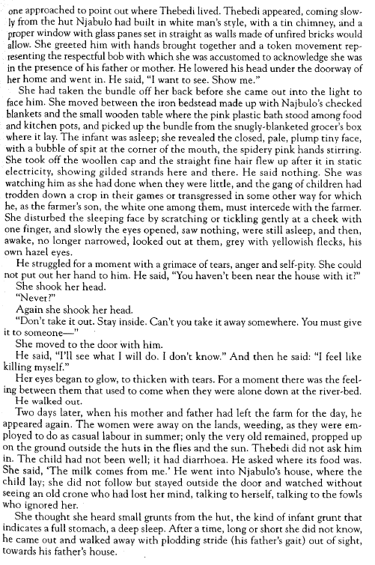

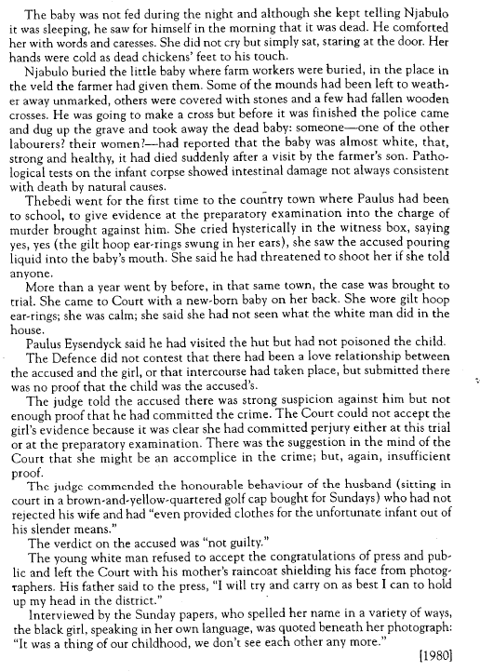

**To help you deal with the structure of this story,** complete these sentences.

|  |  |
| --- | --- |
| The story is set in……..  The boy’s name is……  The girl’s name is …..  The problem is…..  He gave her….  She gave him….  They met at…..  He told her about…..  She responded by…..  They made love….. | The consequences were:   1. …………… 2. ……………   The result of this was….  Her world said….  His world said….. |

**Could the story have ended differently?** Imagine a different end, starting from *“Two days later…”* (p.5)

**Write your book report.**